Influencing dementia policy: social media content and tips
Introduction

This document includes template social media content to be shared by tide carers on Twitter and Facebook, aiming to raise awareness of the Front of Mind campaign with policy and public audiences both locally and nationally. It also includes tips for making your social media activity as effective as possible.

Don’t be constrained by the suggested posts included below: they are there to provide inspiration, but feel free to draft your own content from scratch, using your own voice and personal experiences. If you have any questions on social media activity as part of the Front of Mind campaign, please contact the Incisive Health team at frontofmind@incisivehealth.com, or the tide team at carers@tidecarers.org.uk.

Top tips for social media activity

Social media is an effective tool for engaging with policy audiences: around 90% of MPs are active on Twitter, and on average an MP sends five tweets per day. This presents a key opportunity to engage with – and influence – these stakeholders and get them on board with campaign asks.

To ensure your social media engagement is as effective as possible, the following tips should come in handy:

- Consider the most appropriate platform. As noted above, Twitter is the best way to engage with policy audiences. Facebook, meanwhile, is effective to raise awareness with the public. How could local community groups on Facebook be best utilised, for example?

- Directly tag your target audience, whether an MP, local councillor, or media outlet. Globally, there are around 500 million tweets each day: directly tagging the people who you want to reach increases the likelihood of them seeing, and engaging with, your content
- Think about the time of day you are posting. Policy audiences are more likely to be active on Twitter during working hours – especially when they are commuting – and therefore more likely to find your posts
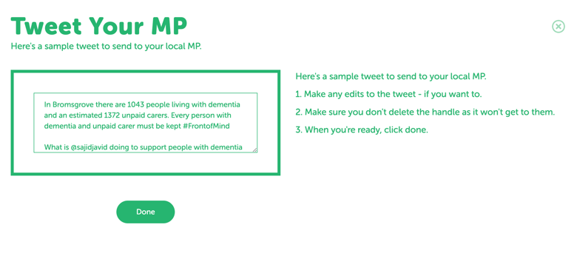
- Be mindful of character limit counts. When drafting your Twitter posts, remember it has a 280-character limit, so keep it short and sweet. Consider the use of threads to break messages down into more digestible chunks. Facebook is more flexible with character counts, but audiences may still be less likely to engage with posts that are lengthy
- Don’t forget to make use of the PoliMapper tool. PoliMapper automatically generates tweets with local statistics on dementia and unpaid care for you to send to your local MP (see image). Making content relevant and targeted to different stakeholders is a great way to make your posts more engaging
Suggested Tweets
- [tag @MP] In [constituency name], people with dementia and their unpaid carers – like myself – are facing unacceptable challenges. The #FrontofMind campaign is calling for this to end: will you help? https://www.tide.uk.net/tide-launches-front-of-mind-campaign/
- I am proud to be part of the #FrontofMind campaign, working to make sure that people with dementia and their carers are involved in the policy conversations and decisions that affect them: https://www.tide.uk.net/tide-launches-front-of-mind-campaign/
- Did you know that 1 in every 14 of those aged 65 years and older is living with dementia? Unpaid carers like myself provide the bulk of care, but are often denied access to critical support. Find out more: https://www.tide.uk.net/tide-launches-front-of-mind-campaign/
- People with dementia and their unpaid carers must be involved in the policy conversations and decisions that affect them. The #FrontofMind campaign is working to make this happen: find out more https://www.tide.uk.net/tide-launches-front-of-mind-campaign/
- Did you know that many people with dementia struggle to access a timely and accurate diagnosis? This has been compounded by COVID-19, but the #FrontofMind campaign is working to reverse this trend https://www.tide.uk.net/tide-launches-front-of-mind-campaign/

- @tidecarers has recently partnered with @_RocheUK to launch the #FrontofMind campaign, seeking to highlight – and tackle – the challenges faced by people with dementia and their unpaid carers. Find out more at https://www.tide.uk.net/tide-launches-front-of-mind-campaign/

Suggested Facebook posts

- Across the UK, people with dementia and their unpaid carers – like myself – are facing unfair and unacceptable challenges in accessing the support and care they need from health and social care services. The #FrontofMind campaign, a joint effort between tide (together in dementia everyday) and Roche, is aiming to put an end to this inequality, and make sure that people with dementia and their carers get the care and support they deserve. Find out more at https://www.tide.uk.net/tide-launches-front-of-mind-campaign/

- 1 in every 14 of those aged 65 years and older is living with dementia. Unpaid carers – like myself – are heavily relied upon by the health and social care system to provide care to these people, but are often denied access to support and benefits. Caring can cause considerable physical and emotional strain, and it’s time for unpaid carers to receive the recognition and support they deserve. Find out more at https://www.tide.uk.net/tide-launches-front-of-mind-campaign/
- I am proud to be part of the #FrontofMind campaign, a joint effort between tide (together in dementia everyday) and Roche. The campaign is seeking to highlight the challenges people with dementia face, and make sure that they and their carers are involved in the policy conversations and decisions that affect them. For more information on the campaign, visit https://www.tide.uk.net/tide-launches-front-of-mind-campaign/ and share your support
- I’m an unpaid carer for one of the 520,000+ people living with dementia across the UK. Many people with dementia struggle to access a timely and accurate diagnosis, which means they cannot access support quickly and plan for the future. It also means that their carers are denied access to support and benefits. The #FrontofMind campaign, a joint effort between tide (together in dementia everyday) and Roche, is calling for people with dementia and their carers get the recognition, care, and support they deserve. Find out more at https://www.tide.uk.net/tide-launches-front-of-mind-campaign/
- I have been part of tide (together in dementia everyday), a charity working to improve the lives of people with dementia and their carers, for [x] years, and am proud of the steps we have taken to make sure that people with dementia, and unpaid carers like myself, get the care and support they deserve. tide has recently partnered with Roche to launch the Front of Mind campaign, which seeks to tackle the unfair challenges that people with dementia and their carers continue to face across the UK. For more information on the campaign, visit https://www.tide.uk.net/tide-launches-front-of-mind-campaign/ and share your support

Roche Products Ltd has funded Incisive Health Ltd to support together in dementia everyday – tide – in the development of its carers network through training and content creation. Roche has not had direct involvement or editorial control in the development of this content.

May 2022

